# From Fragrant Florence to Simply Spectacular Switzerland

Florence was a great experience. I was able to successfully navigate a massive-sized city, I saw some pretty amazing things, found some logistical things that I needed (bug bite cream, a laundromat, a grocery store, etc.), and did all of this while staying safe. My summary of Florence includes a few smells that I will forever associate with the city there: leather, gelato, garlic, and tobacco. If ancient art had a smell, it would be on the list as well.

One of the many bridges over the Arno River in Florence, Italy.

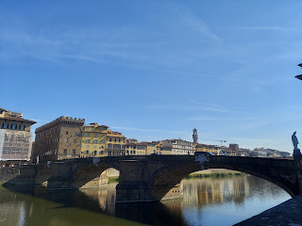

Monday:

After a HORRIBLE night of sleep due to mosquitoes in Venice, I hurried to get ready and out the door by the rigid check-out time of 10 a.m. At my AirBnB, air-conditioning was not available because it was during the "off-season". (Late Sept. is past the AC season, but not quite heater season either) You either open the windows to get some fresh air and thereby allow mosquitoes to enter the room, OR you shut the windows and suffocate. It had rained quite a bit through the weekend, particularly on Sunday afternoon and evening. So the mosquitoes were out in full force after the rain was done.

I remember trying to sleep, but I kept hearing a mosquito buzzing right by my ear. So I would clap my hands, hoping to kill it, bolt up in bed, turn the light on, and check to see if I got him or not. Eventually, I just sat up and read or played games for a couple hours - on my phone with the light on, waiting for one to come near enough so I could squash him. I got several using this tactic. By this time, I had closed the windows and just focused on killing whatever was still in my room. Let's just say that by the time I fell into a stressful coma, it was around 2:30 a.m.

After I finished getting ready and out the door by 10:15, I had plenty of time to make my way over to the train station, which was about a 20 minute walk.

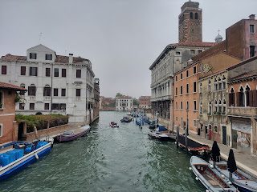

I was quite hungry by this time, so a market stand, full of fresh and colorful fruit, looked absolutely amazing! I bought a giant nectarine and then sat down to eat it nearby. In Venice, you can't just sit down at an empty table. The tables and chairs are only for paying customers, so I bought a bottle of water (still water they call it) so that I could rest for a bit.

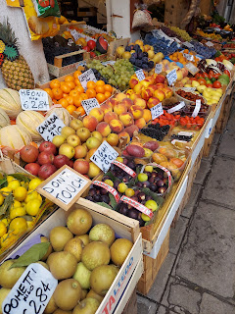

Closer to the train station, I found this shop that sold crepes. I chose the ham & cheese crepe so it had more protein and less carbs. :) It was delicious!

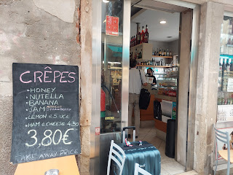

This is the view from the train station in Venice: Santa Lucia.

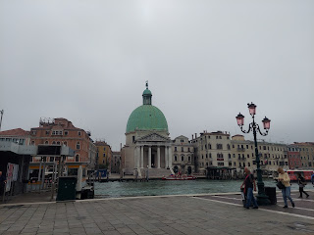

I left Venice via a high-speed train for Florence. It was my first time riding on a train from another country, but I learned a few things.

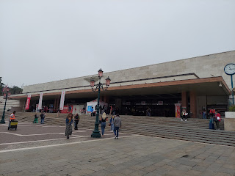

1) Sometimes it's a good idea to pay for 1st class, sometimes not. In this case, it was good since it was my first experience and there was an assistant in the train car to help me.

2) I thought I was supposed to heft my big suitcase onto the shelf above my seat. I tried with all my might, but I wasn't tall enough or strong enough. So I just sat down and kept my suitcase next to me, hoping that at some point the assistant would come back through to help me. Eventually he did, but he led me to a space near the back of the car where I could just wheel it in and park it there. Hallelujah! That was awesome! Now I was confident that I wouldn't kill myself trying to get that darn suitcase up on an overhead rack. :)

3) When trying to figure out where your train is on the platform, look at the departure screen. If you know what train # you're supposed to take, then that's the main thing that matters. It will tell you what platform to go to and wait for your train. It was confusing at first because my train # was showing a different destination. That's normal apparently, because the train makes several stops with an eventual destination, which might be different than where you're headed. As long as you know it's the right train #, then you'll be fine. You just get off at your stop along the way.

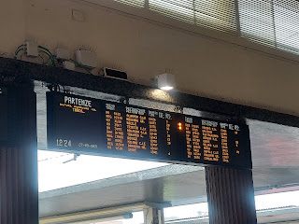

4) The departure screen may not show your platform number until just a few minutes before it's time to depart! And then you might need to RUN!

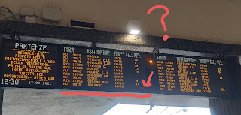

But in the end, I found my train, and all was well.

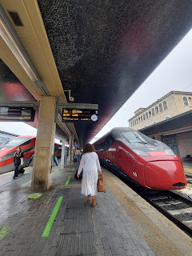

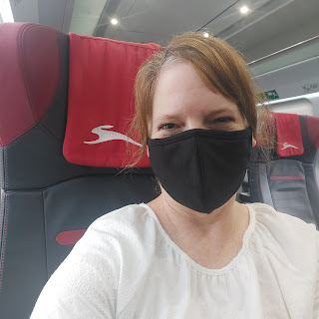

As we left the station, I was grateful to hear that after any announcement was made in Italian, it was quickly followed by Mr. British Guy saying the same thing in English.

Click to see us pulling away from Venice, and to hear the announcements in both languages: (43 seconds)

https://photos.app.goo.gl/fuhX1yH8NPPBVNCKA

Later on, the screen showed just how fast we were going! (Translation: The train is traveling at 252 km/h)

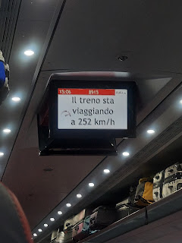

I arrived in Florence at the Santa Maria Novella Station, and thankfully, only had a 5 minute walk to my next AirBnB. Florence is HUGE. It had a whole different flavor than Venice. Venice was more relaxed, and even though it had a lot of crowds, it never really felt crowded. It felt like everyone was there just to have an intimate experience with Venice. In Florence, it felt like a typical big city, where most people are in a hurry to get to wherever they're going. The crowds felt more pressing here, more constrictive.

My AirBnB host spoke perfect English, which was awesome! He grew up in Florence, but also lived in England for 30 years, and even went to college in the U.S. (San Francisco and New York). He was quite cheery and I welcomed my first real conversation in English while being in Italy.

He lugged my big suitcase up several flights of stairs. What a good guy! It was a 14th century building that I stayed in, by the way. :) Gotta love that.

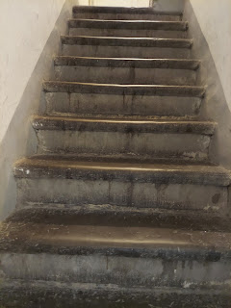

I walked one block over and ordered my first Italian pizza. It was just okay. Benson told me later that he thought pizza in Florence was bad. Either way, I had something to eat for dinner and I didn't have to go very far.

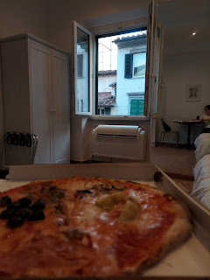

I enjoyed watching "Luca", the new Disney movie, while I ate my pizza. Luca takes place in the Cinque Terre, which I would be visiting in a couple days. It was a cute movie!

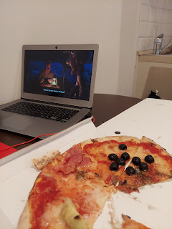

At bedtime, I grabbed a little bedside book to peruse at the AirBnB, entitled: "Strolling through Florence". I thought this little story was interesting, so I sent it to my kids.

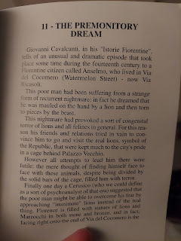

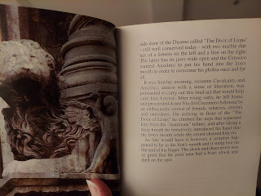

And this map seemed helpful for the section of Florence that I was in.

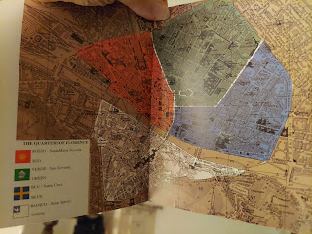

Tuesday:

I got up early so I could go on a walking adventure.

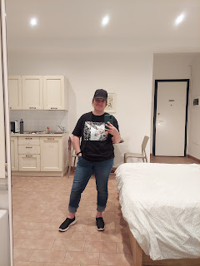

I found a nearby place to get some breakfast, per the suggestion of Stefano, my AirBnB host. It's called "Pasticceria Gamberini". It's basically a pastry restaurant. Stefano says that most Italians have a sweet tooth for breakfast, preferring to eat a pastry with their coffee or wine to start the day.

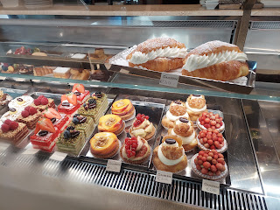

As I stood back and watched what others were ordering, I got curious about the 3rd item from the right on the top shelf (below). As I saw a lady order one, it appeared to have some egg inside, which was better than just sugar for breakfast. So I followed her lead, and ordered one for myself. It was delicious! It did have some thin scrambled egg, and a thin cheese, with some sort of creamy spread on the bread. Maybe a cream cheese mixture of some sort, but much more delicate. It was fantastic!

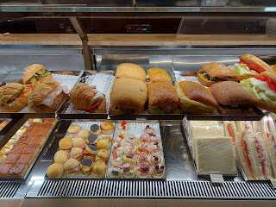

Another block or two and I was at the River Arno.

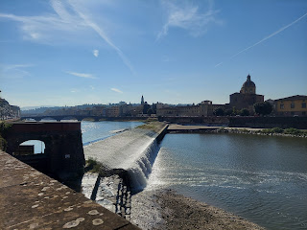

I followed the river for a little while. I thought it clever that the city provides a separate bike lane for all the many bicyclists, to keep them safe.

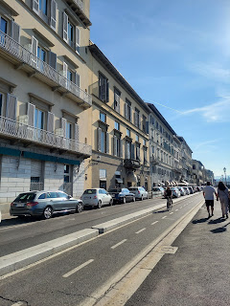

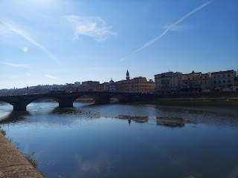

LOTS of scooters everywhere.

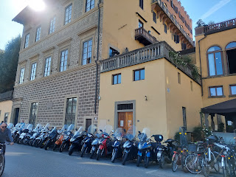



Very narrow streets.

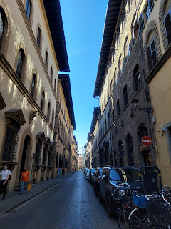

LOTS of street vendors, happy to sell you something.

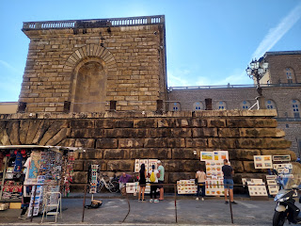

I paid to do a self-tour of Giardino di Boboli (The Boboli Gardens), adjacent to the Pitti Palace, home of several high-ranking Medici family members and Grand Dukes of Tuscany back in its day.

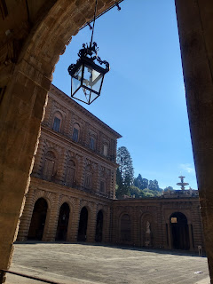

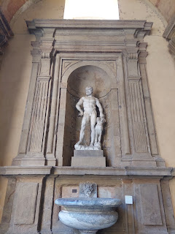

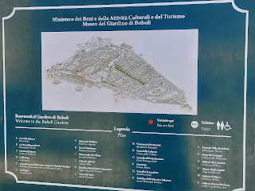

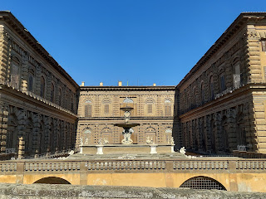

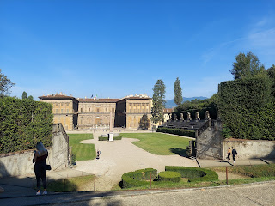

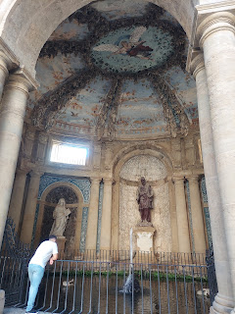

The Italian Garden was designed in the 16th century and showcases a lot of sculptures made in the 1500s.

It has several terraced levels, all of which are a huff-and-a-puff up yet another set of stairs.

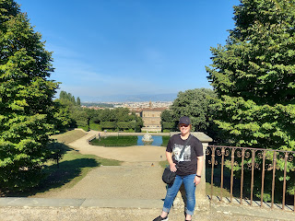

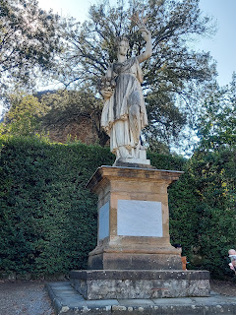

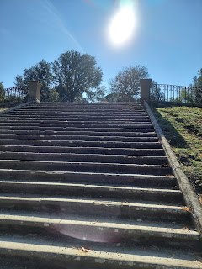

There are several paths on each terraced level, with a place to sit if you need it.

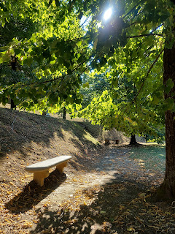

The Fountain of Neptune

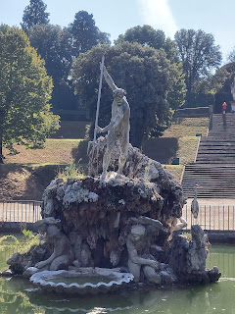

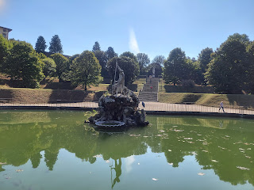

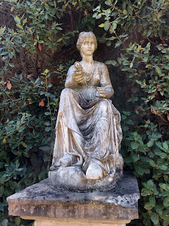

Views of Florence off in the distance, from my terraced point in the Garden.

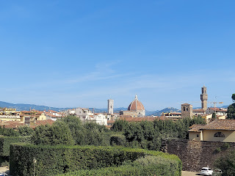

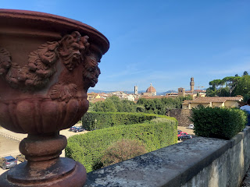

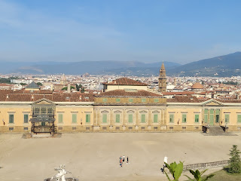

Verrrry interesting . . .

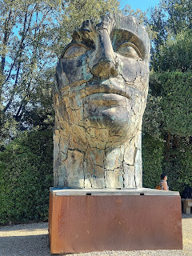

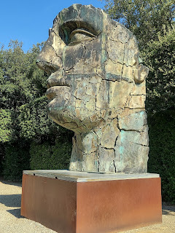

The Grotto of Buontalenti, built from 1583-1593.

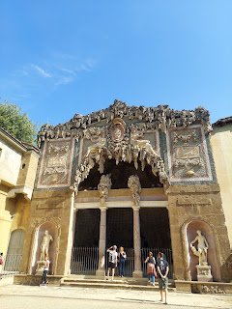

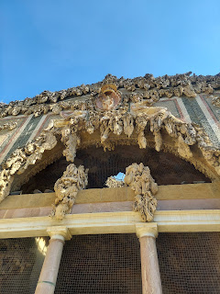

The inside of the Grotto

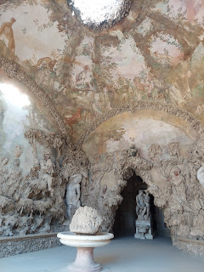

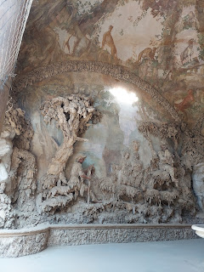

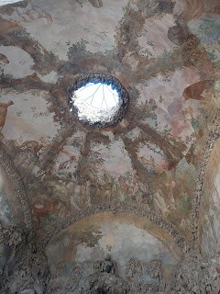

Even the polizia needs to recharge, ha ha

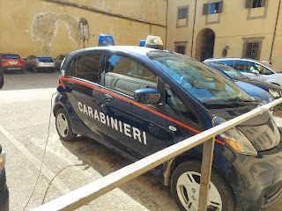

More sculptures near the exit

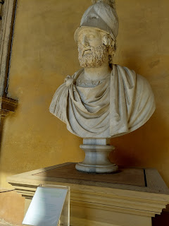

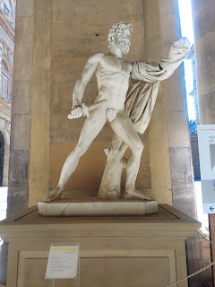

I wandered over to the Ponte Vecchio Bridge along the Arno River. This is an area FILLED to the brim with all kinds of fancy shops. Lots of leather, lots of jewelry, etc.

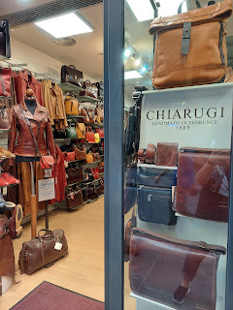

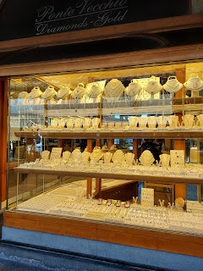

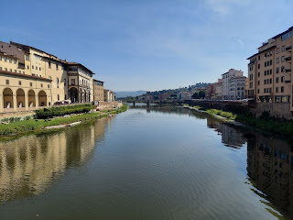

This whole street below, both sides, was filled with JUST jewelry shops.

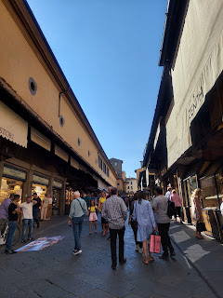

I found myself some gelato - this time strawberry and orange cream (my all-time favorite at this point).

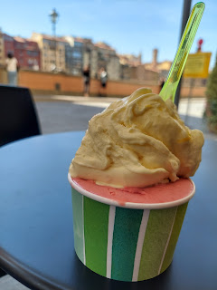

It was fun to sit a while and just watch all the passersby. Including the occasional horse-drawn carriage ride.

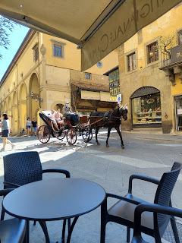

Short video of the horse and carriage trotting by: (10 seconds)

https://photos.app.goo.gl/W4mAdR2CAbwHMQSJ9

I got a kick out of watching all the people taking selfies and other pictures next to the river.

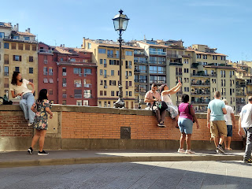

As I was sitting there, this man walked right up to me and with great joy and flattery, presented me with several bracelets, along with 2 small ceramic painted elephants, saying that they are good luck! His name was Modi and he is from Kenya, now in Florence for some reason. After he gained a little of my naive trust (he appealed to my sense of cheery conversation), he then asked for a donation for all the gifts he had just bestowed on me. (!) What a salesman. I gave him a little bit of money and sent him on his way. (He's the one, by the way, that suggested we take a selfie with all of my "good luck" gifts. :) lol

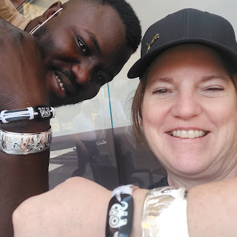

A couple days later, when I was mailing some boxes back home to the States, the lady in the shop told me that there are far too many people doing just that - walking along giving "gifts", only to ask for money from those they just "gifted". She said that a few years back, the "gypsies" arrived (maybe she meant the refugees?) in great numbers and they were all trying to earn a living. They would start washing people's car windows when they were stopped at a red light, asking for money as they washed. When the light turned green and the driver needed to go, the gypsies were still washing the windows, holding up a long line of traffic. It didn't take very long, she said, before the local government in Florence banned all such activities.

Overall, I felt a bit of frustration that I got "taken", but then I try to dismiss it because he was just so full of joy and the bracelets really are beautiful. (I'm sending them on to Abby and Gwen by the way)

Another horse-drawn carriage coming by

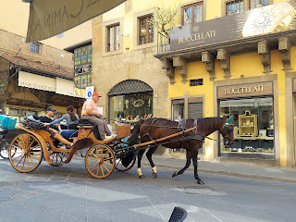

Florence is known as a "Bike City". And yes, they sure have a lot of bicyclists!

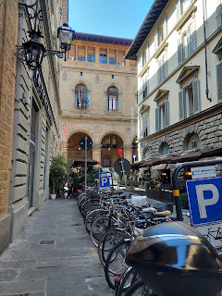

I thought it comical that parked in front of this Giorgio Armani store are a bunch of Vespas. :)

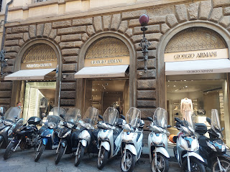

Side note: Back in Louisiana, Miss Abby had a dress-up day at school. The theme? 80's Can't you tell?

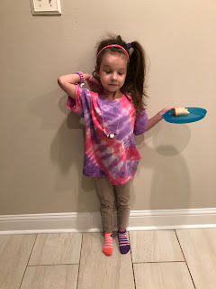

After a little rest and quiet time in my apartment, I headed out on my second grand adventure of the day. I walked about 20 minutes to get to the Galleria Accademia so I could see Michelangelo's masterpiece: David.

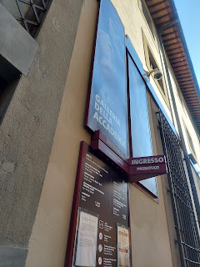

It was indeed a masterpiece. I didn't expect it to be so tall!

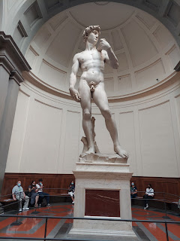

A video of David in all his magnificence: (30 seconds)

https://photos.app.goo.gl/Qa2QJfGRxrPqNmMw9

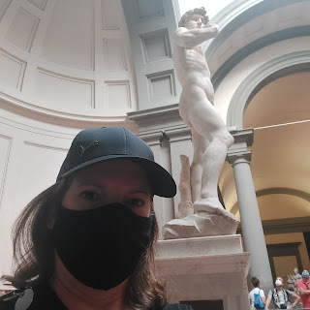

I had paid a few extra Euros for a handheld audio guide in English, which I used only minimally. All the signs had both Italian and English explanations, so that provided me with enough information. The audio guide just added more historical background to various pieces throughout the gallery, without really telling much about the piece itself.

To see all the photos I took of the beautiful art within the gallery, you can click on this link:

https://photos.app.goo.gl/1PqnteUsijuTNgSX9

It was definitely a meaningful experience, and I found myself getting emotional a few times. Sometimes, it would just hit me like a punch in the face. Sometimes I would get a little nudge, with the thought, "You are here in Italy! You are seeing something special right now." And sometimes, I just really wished that Amber was there with me. Last year, we were supposed to go to this very place together, and see David together. I felt the emptiness next to me and it made me get teary more than once. I took lots of pictures to share with her, which I have, and which are included in the album link above. I even bought Amber and the girls a few books from the bookstore there, just to send them a little piece of my experience in being there.

On my walk back to the apartment, I found a grocery store on the way. I had to get temperature scanned to enter. Same with the museum. I have to wear a mask anytime I go indoors over here. It's just mandatory, no questions asked. After my temperature registered within the normal range, then the little gate opened for me to enter.

I found fresh produce for the first time in Florence, and happily selected a large nectarine, some kiwis and grapes. I found a salad for my dinner, along with some fresh salami for some protein. What took me forever - and I literally mean forever - to find . . . was some milk. In the fresh milk area, there appeared to only be creams and thicker creams. (labeled as "latte") I walked all over the small store, but my only other option was shelf-stable milk. I finally chose a small carton of coconut milk and a box of fiber-rich granola and then made my way up to the front.

All the shops in Florence are tiny and packed one right after the next on every street. This store was bigger than most, but when I got up to the front to pay for my items, it was very narrow and difficult to conduct business at my station. I kept having to move my little wheelie-basket out of everyone's way, and we all just tried to navigate around each other to pay for our things and then get out of the store. I didn't realize either, that I was supposed to weigh my fruit and attach a sticker to each type of fruit indicating the weight and total price for the clerk at the checkout area. The cashier scooped up all my fruit and went over to do it for me, while I tried to keep out of everyone's way, ha ha. Eventually I made it out of the store alive.

I've thought a lot about the layout of the city of Florence. I marveled at how on every street, there is a mixture of housing, restaurants, and shops. I wondered why that is. My conclusion is that: 1) it keeps all areas of the large city alive and vibrant; 2) it cuts down on congestion because everything is nicely spread out; 3) it's convenient to have a selection of shops within 5 minutes of anywhere you live; and 4) it actually helps to keep the citizens safe! If my street was only residential, it would be very quiet. If anything happened to me, nobody would really be around to help. But right underneath my apartment was a restaurant, and there were multiple shops all along the street. There are always people walking by at all times of the day and night. That in and of itself made me feel safe and comfortable.

Wednesday:

I got up early to catch an 8:30 train toward Pisa on the coast. It paid to do my research beforehand, to make the most of my tight schedule throughout the day. It took one hour to get to Pisa. I hopped off the train and immediately found a taxi to drive me across town to see the Leaning Tower. It took less than 10 minutes to get there by taxi, as opposed to a 30 minute walk, which I didn't have time for.

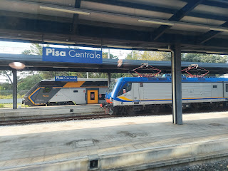

The entrance where the taxi dropped me off.

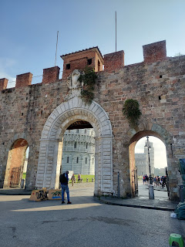

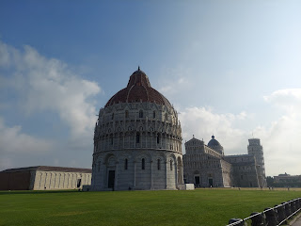

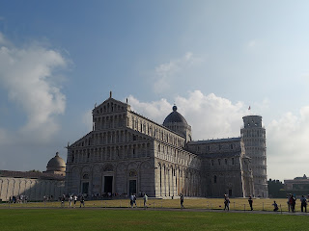

I asked a couple different people to take a photo of me in front of the Tower.  I didn't find anyone that could speak English, but it was fun to use gestures and laughter to figure out where my hands needed to be for the poses.

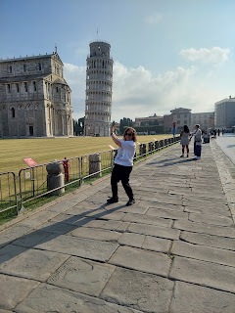

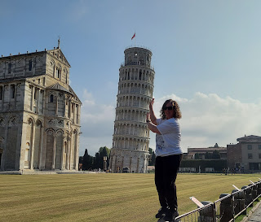

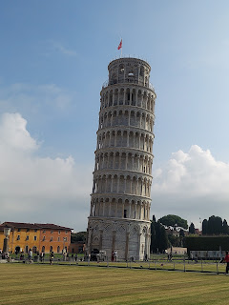

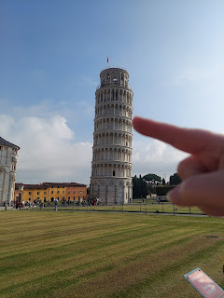

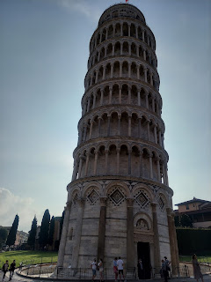

Then I scurried over to get a ticket to climb the steps inside the Tower up to the top, so I could get a nice view. I had to leave my backpack and purse in a locker (for free) and was only allowed my phone and my ticket (along with my vaccine card) to go with me into the Tower.

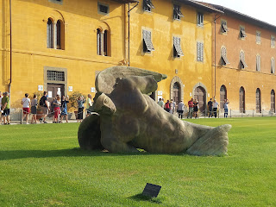

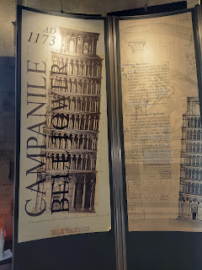

We were given a short intro to our experience, and then we were each given a "buzzer" to hang around our neck like a necklace. If we ever got less than a meter away from another person, our buzzer would go off and it would flash red. If we were properly distanced apart, it would just stay green.

We walked 294 steps up to the top of the Tower as a group. I needed to stop a couple of times to catch my breath because not only is it hard to breathe when you go up that many stairs, but with a mask on it made it even harder! I noticed the pull of gravity as we circled up the spiral staircase. It felt tippy on the one side, and more normal on the other.

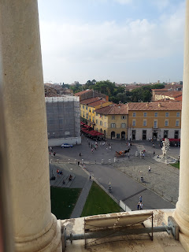

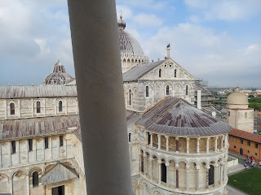

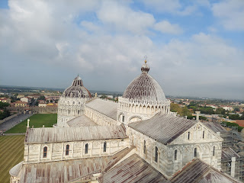

Here you can see the buzzer around my neck to indicate if I'm within a safe distance of others. :) I was resting at the top of the tower here.  And yes, I pulled my mask down. I was hot and sweaty and out of breath.

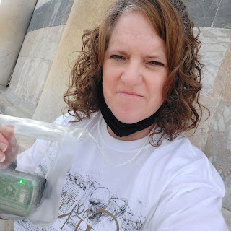

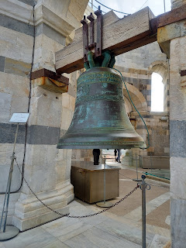

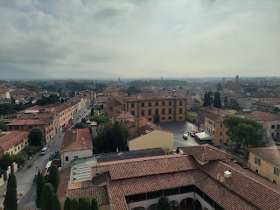

I didn't have time to tour the Duomo next to the Tower. Maybe next time . . .

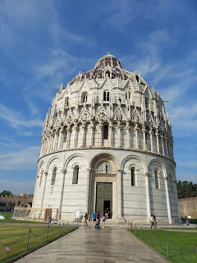

Time to catch the next train . . . headed to La Spezia, which is a central hub for travel to and from the Cinque Terre.

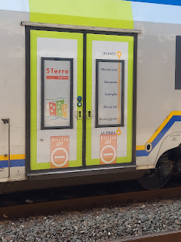

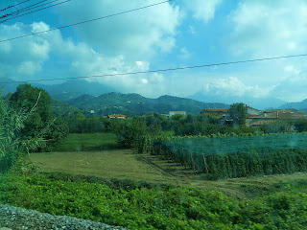

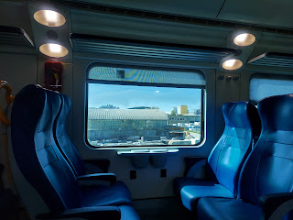

I encountered a small problem, however. I got off at the wrong stop! I didn't realize that there were 2 stops for La Spezia and I got a little too eager to disembark. So I ended up here, in the middle of nowhere.

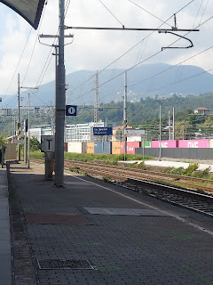

But within moments of realizing my mistake, I heard someone speaking English near me. And then another, and another, and another! There were about 6 of us total, all from America, who made the same exact mistake! :) So we chatted and got to know each other a bit while we waited for the next train.

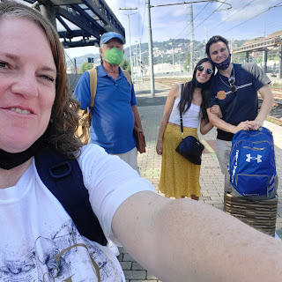

The older gentleman in the blue shirt was from Florida, coming to visit his son in the Military up in Germany. They had plans to visit the Normandy coastline together.

The younger couple were from San Jose and San Diego. The young man is studying classic art and culinary in Florence, while his girlfriend is a journalism major. They were super cute and so nice!

Eventually another train came by to pick us up, and we arrived, humbled, at the correct station. That was actually a helpful mistake to have made then. I had more time to fix my error that day. Not so much a day or two later - when I almost made the same mistake again in Milan - before remembering to double check!

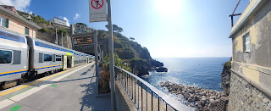

Cute - that they are advertising Luca the movie in the Cinque Terre. :)

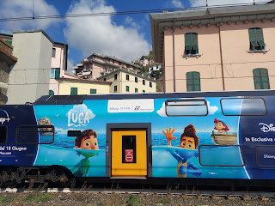

I stopped to find someplace to eat in Corniglia, one of the 5 towns in the Cinque Terre. It's right in the middle and can be seen from any of the other villages. It was recommended by an information booth attendant when I was a little pressed for time (because of my train stop error earlier).

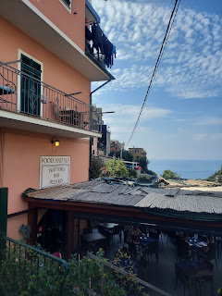

I was quite hungry, and didn't know when I might be able to eat again. So I ordered an omelette with vegetables, with a caesar salad on the side. It really hit the spot! (photo above is the restaurant where I ate)

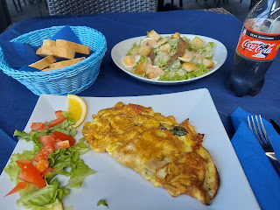

Then it was off to do my epic hike from Corniglia to Vernazza. ETA: 1 hour, more or less.

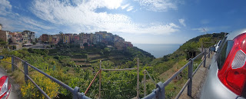

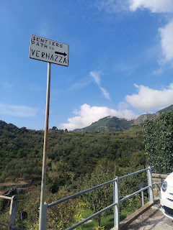

I didn't know until later just how brutal this hike would be. It was described as "moderate". Yeah, right.

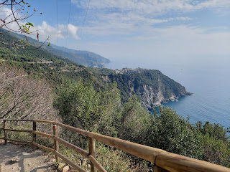

Mostly the trail was a series of uphill stairs, and more uphill stairs, and more . . .

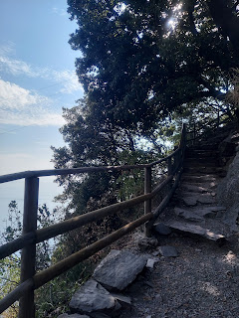

But the view was amazing! I stopped often to just enjoy the view, while I took whatever time was needed to get my breathing back down to normal.

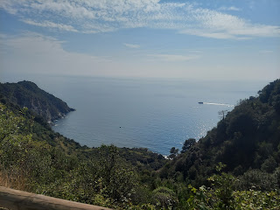

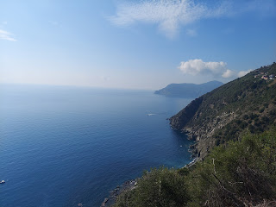

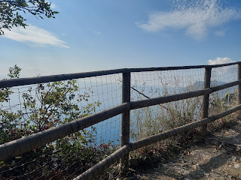

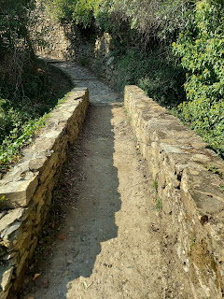

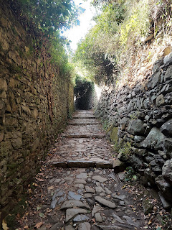

Perhaps a conservation project? This was near the end of my hike, when I was most exhausted. To me, they just looked like potential hammocks for me to climb into.

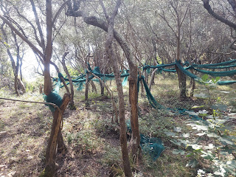

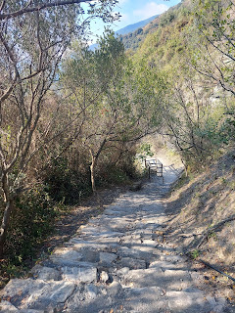

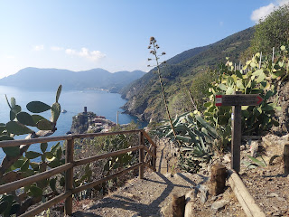

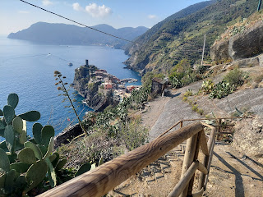

Finally, I could see Vernazza down below.

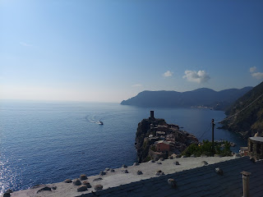

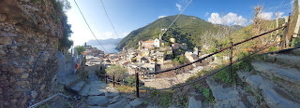

Even when it was time to go DOWN, I was so shaky and spent that it took a lot more care to go down each step so I didn't buckle and just roll down into Vernazza.

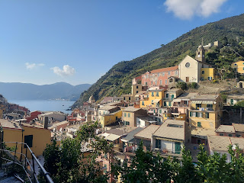

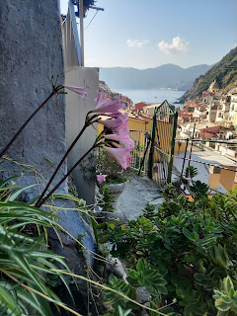

The steps going down led me right through some quaint little neighborhoods and alleyways.

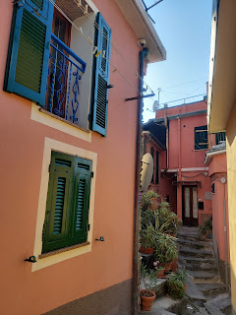

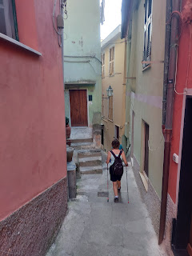

Hooray! "Main Street"! I made it! I was so happy to be done and to celebrate, I began looking earnestly for some gelato.

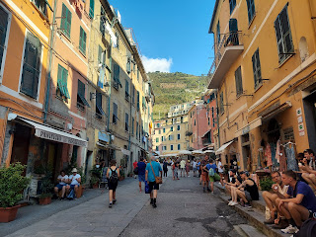

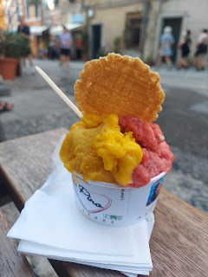

You can't see how flushed my face was here, or all the sweat dripping down, but it's there. Trust me. It was hard earned and I was proud of myself for finishing. :)

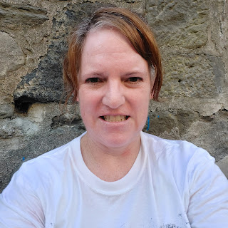

At the top of this photo is where I first came off the trail into Vernazza. This is the view from the train station looking upward.

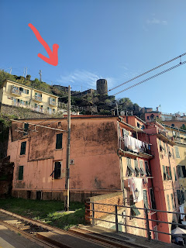

Last stop in the Cinque Terre: Monterosso. Oh, how I wish that I had known sooner how beautiful it was here! As it was, I was out of time. This was where I would catch my train back to Florence, through Pisa. I only had about 20 minutes to enjoy Monterosso. I pledged deep down in my heart that I would come back.

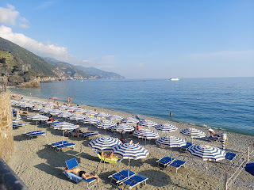

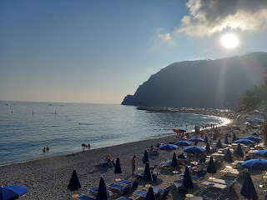

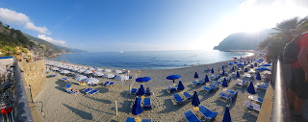

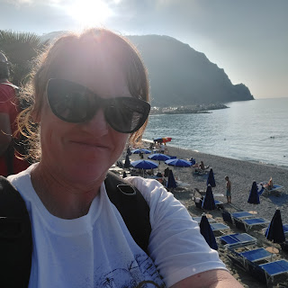

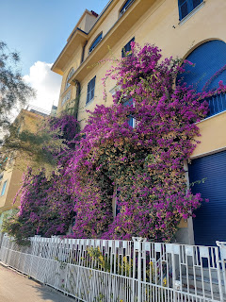

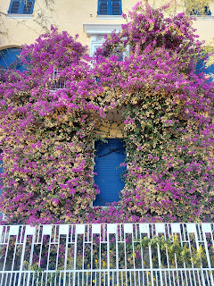

I walked down to the water's edge just so that I could touch the water. It was a very comfortable temperature: not warm, but definitely not cold. It felt refreshing and I wished that I could hop in!

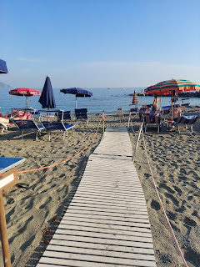

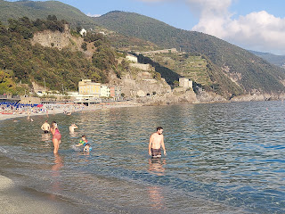

By the time I got back to my apartment in Florence, I had racked up 16,000 steps for the day. This was just before I arrived and got settled in for the night.

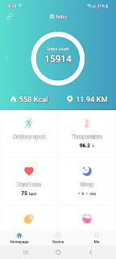

I want to show you my handwritten note that helped me keep my head on straight during such a technical day of travels.

I listed everything on a piece of paper: all of my trains, with all pertinent information, plus my original plans for the afternoon. Of course, they changed slightly because of my faux pas. :) But you get the idea. The reason why this helped so much is because my train tickets were a little complicated to pull up each time on my phone. (I had to open my email, find the email, open the PDF, etc) This allowed me to know immediately what train # I needed ahead of time. Super helpful!!! Sometimes I can just screenshot the document to make it easier to pull up when I need it, but these train tickets were not meant for that for some reason.

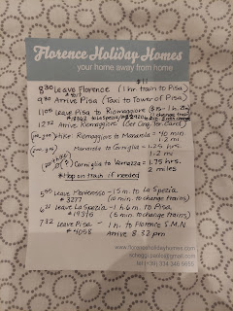

Thursday:

I really thought it was cool how this cupboard was designed in my AirBnB. It had racks built in for the clean dishes to drain, and there's a little tray underneath the lower rack to catch any drips.

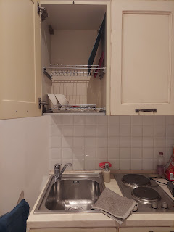

After a relaxing morning in my apartment (I worked some on my blog), I headed out to meet the host of my Italian cooking class.  The assigned meeting place was at the Rolex shop on the old Ponte Vecchio Bridge. I knew right where that was, having been on that same walk two days prior. :)

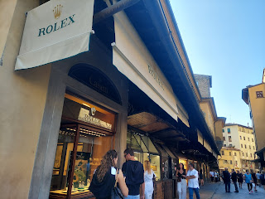

My host, Stefano, walked with me to his car: a 1971 Fiat!! The car is the same age as I am!!

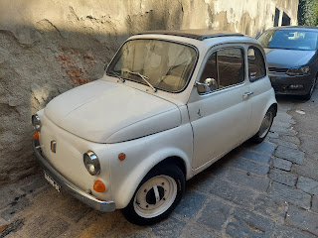

We drove up into the hills above Florence to the house where he lives with his girlfriend from Russia and his mother, Daniela.

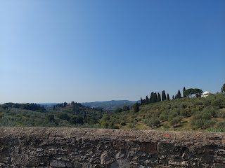

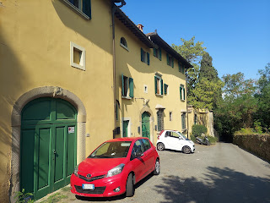

They rent a portion of an old 16th century building, and this is their garden out back, where everything was set up for the cooking class.

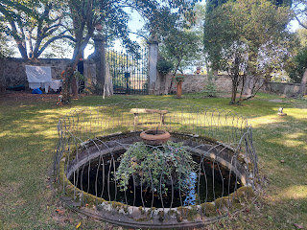

It was so fun!! It was very calming to be in a quiet space with just the two of them, learning how to make gnocchi and ravioli from scratch, and just working with my hands.

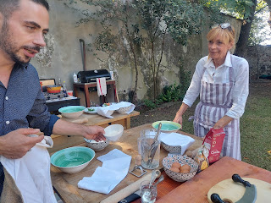

To see the rest of the photos I took, you can click on this link: (It also includes a couple videos of us bouncing along in the squeaky old Fiat, ha ha)

https://photos.app.goo.gl/SDpkLBRKWtkr3JCc7

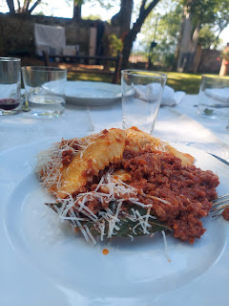

Here are a few of the photos that Stefano took with his own camera and shared with me.

After I got back into town from the cooking class, I gathered up a few excess items that I didn't want to drag all over Europe, and I shipped them home. That felt amazing! Lighten the load = happiness!!

And then I found a nearby laundromat that my AirBnB host recommended, and I washed all my clothes! That also felt amazing!

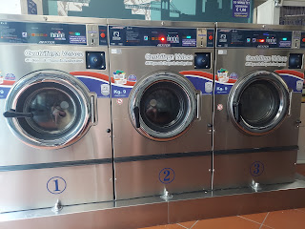

I ate dinner at a Japanese restaurant below my apartment - very conveniently located, I'd say. And while I ate, I chatted with Amber and Gwen for a while. Gwen is always so happy to talk to me. That makes my heart happy. :) She always asks me, "Mimi, when are you going to come to Louisiana?" Right now, I'm thinking that March looks good. (Scott's spring break)

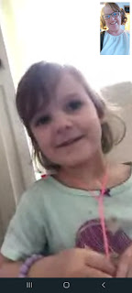

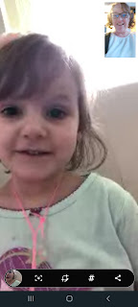

I tried some tofu in a salad. It wasn't that bad.

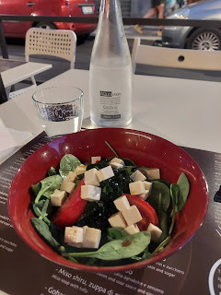

The Katsu chicken was super tasty! I didn't have a spoon to eat the soup, so after carefully sipping some, but not wanting to look strange, I didn't eat anymore. Besides I was getting very full already.

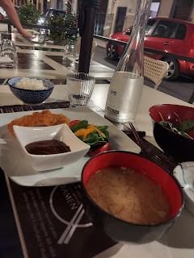

After dinner, I spent the rest of the evening packing and organizing everything because I would be heading to Switzerland in the morning.

Friday:

Goodbye to Florence. I was definitely ready to move on.

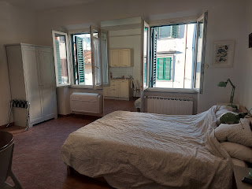

As soon as we got out of the city and into the mountains, I knew this was gonna be good.

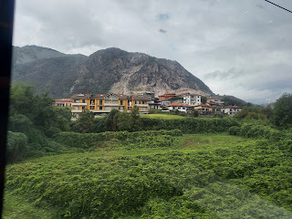

Welcome to Thun, Switzerland!

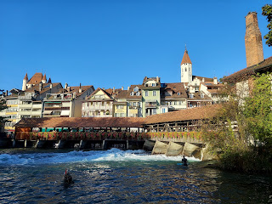

Surfers were practicing their skills in the heart of downtown.

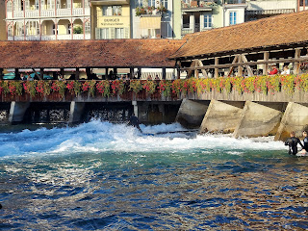

The only thing I'd had to eat since breakfast was a few crumbled crackers from my backpack. I arrived with a good dose of motion sickness from the high-speed trains. They are very smooth, but you can tell you're going fast at the same time. Sometimes you're in an endless dark tunnel, speeding through the mountains, and other times you just see a blur of tall bushes flying by out the window. It all adds to my tendency towards motion sickness. When I arrived at my new AirBnB in Thun (pronounced Toon), I had a headache, I felt super woozy, and I was even a little nauseous. It took laying down for an hour with my eyes closed to help fix the issue.

The first thing I felt in love with in Thun was the crisp, cool air outside. It felt amazing! Italy was hot and sweaty, but here it felt like a nice Idaho evening. Soon, I felt like going for a walk, and that's when I ended up at this place, watching the surfers as I ate some caesar salad with chicken.

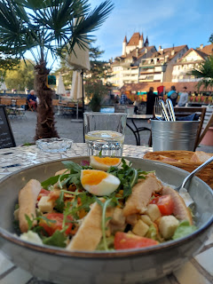

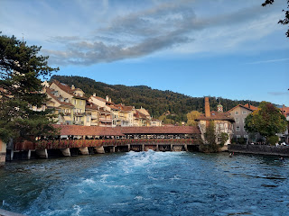

As I meandered around Thun after dinner, an older man passing by started speaking to me in the Swiss German dialect from this area. I let him know I only speak English, and then to my surprise his face lit up and he asked me in perfect English, "Where are you from?" I told him America, and then he wanted to know where exactly. I told him I am from Idaho. He got really excited and told me he has been to Idaho (Boise) and that he loves it there! He asked if he could buy me a drink so we could talk some more . . .

I declined but I told him I could walk with him for a minute while we talked. Well, here is how it all ended up, ha ha. And don't worry - all is well!!

He is married to Brigit, who is taking an English class here in Thun. She particularly would want to talk with me, he said, so she can fine tune what she is trying to learn herself. He tried to call her but she wasn't home yet. The man's name is Martin, and he is an attorney of some high status at their local courthouse. He spent a year in the U.S. when he was younger, and traveled to all 50 states! He mostly slept in his van during all his traveling.

He wanted to know what my thoughts are about Trump and Biden. He wanted to know how to say or pronounce several things correctly in English. He was SO curious about everything, ha ha. He even stopped at one point to ask me directly: "Why didn't you want to come have a drink with me earlier? Is it because of fear?" I told him that yes, that was basically it. I am traveling alone so I am trying to be smart and wise in all that I do. He had great respect for that.

Everywhere we walked it was in a very common area with plenty of people around. At one point his wife called him back and was very excited that he met me. I will be meeting them both later today (Sunday) up at Thun Castle, in the heart of Thun, just a short walk from here.  During our walk that evening, he showed me where the best view of the city was, which also happened to be up at the Castle.

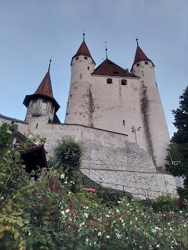

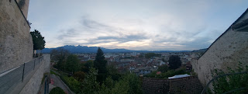

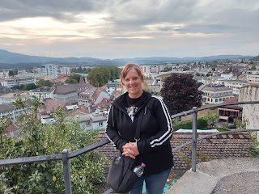

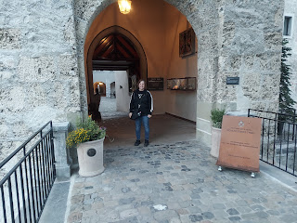

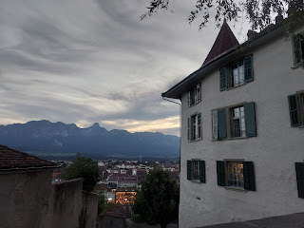

Even though I could tell he still had a million more questions, I told him I needed to leave to get back to my place before it got dark. He walked me from the castle back into Old Town and then we parted ways, having exchanged phone numbers on WhatsApp so we could set up a time to meet again - this time with his wife.

I hurried home, stopping quickly for a few groceries, and then settled in for the night.

Saturday:

Originally I was going to take a series of trains up to Jungfraujoch, to see the "Top of Europe" and to hike the Eiger Trail across part of a glacier to Alpiglen. But after I experienced such profound motion sickness the day before, I wasn't too excited to start all over again - and at the crack of dawn, too! At the suggestion of my host, Doris, who speaks really good English, I changed my plans for the day.

After a leisurely morning without rushing, which gave me time to work on my blog some more, I caught a bus at 11:00 a.m. along Lake Thun toward Beatenbucht. (pronounced bee-OTT-en-bookht) From there, I bought a ticket for the funicular and gondola to take me straight up the mountain to Niederhorn, one of the highest points around.

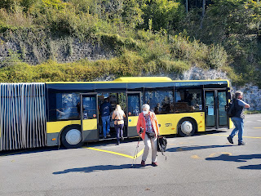

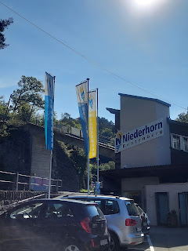

This is inside the funicular car, where everyone just loads in and loads in until there's no more room, ha ha!

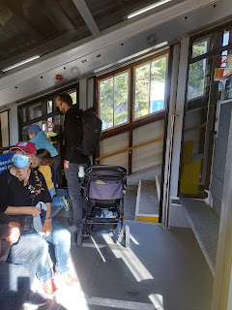

We had several people, a mountain biker, and even this sweet dog in the car with us. There are several cars attached together. And then it just goes straight up the mountain, similar to a motorized chair going up the stairs, like in the movie "Up."

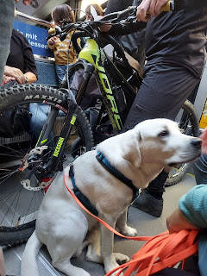

Video of us going up in the funicular: (20 seconds)

https://photos.app.goo.gl/HMvCLvQhMKTeDKWU8

Looking down on Lake Thun below.

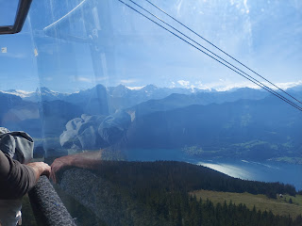

The gondola was quite smooth as well.

Video from within the gondola, and looking down at Lake Thun. (24 seconds)

https://photos.app.goo.gl/wJxmB7JbFTNH2rF97

It's when you get up to the top that the REAL views are just so incredible!

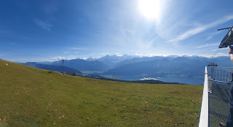

Niederhorn is 6397 feet in elevation.

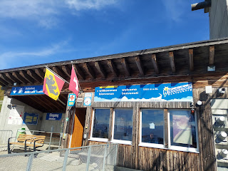

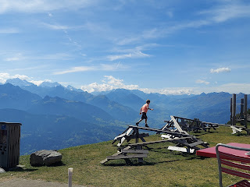

I thought this little boy was quite adventurous, as you will see in the next photo . . .

(It really isn't an open cliff for him to just jump off, as it seems here ha ha)

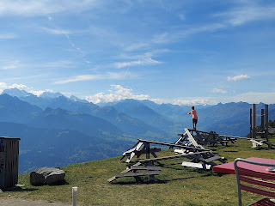

After grabbing a bite to eat at the mountaintop restaurant, I set off to explore the many trails available.

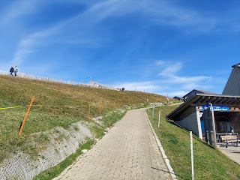

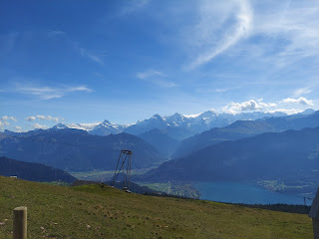

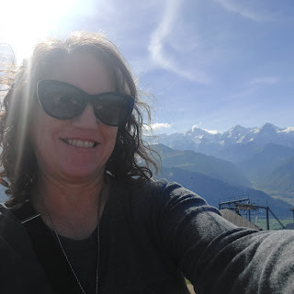

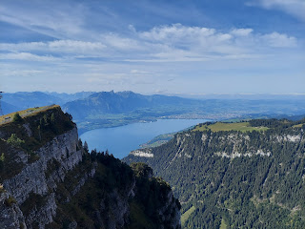

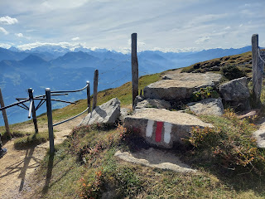

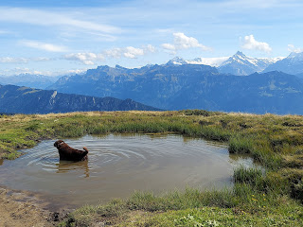

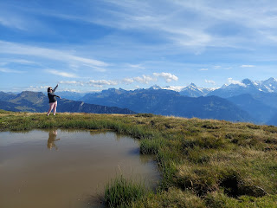

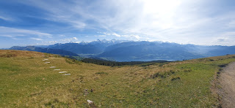

Video of the views: (36 seconds)

https://photos.app.goo.gl/hF7mFmcVLVCxRLhX6

Something I have noticed about Switzerland, which I find remarkable, is how actively and sincerely the young fathers are involved in raising their children. Yesterday, I saw father after father either traveling with his young children (alone) on a Saturday field trip, or carrying his infant child in a pack on his front or his back along the mountain trails, while his wife was hands free.

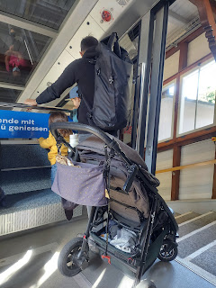

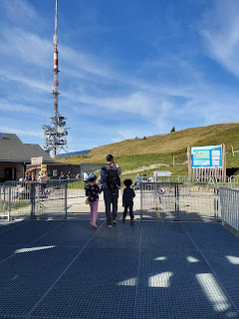

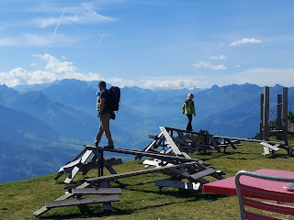

In each case, the father did not seemed stressed or worried one little bit about the caring of his young children. It seemed very natural to him. He was patient, spoke in a calm and loving voice, answered their many questions, and I found it all to be very endearing.

Before I headed back down the mountain, I had to give a little yodel on top of the mountain - aimed at my Swiss ancestors. :)

Video of my quiet little yodel: (8 seconds)

https://photos.app.goo.gl/HG2najUUtHz7QsL18

Eventually, and reluctantly, I got back into the gondola to head back down the mountain.

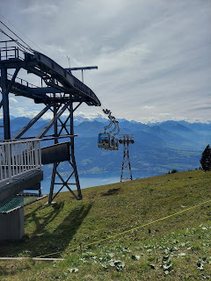

There are actual residents that live on this mountain, and some of them raise cattle on the steep slopes!

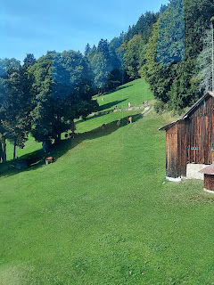

At the bottom of the funicular, there is a restaurant on the lake. I got a couple scoops of ice cream to enjoy before getting on the steamboat to take me back to Thun.

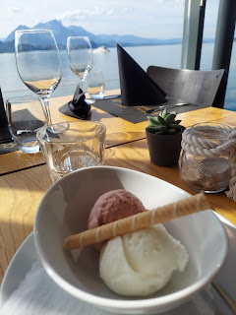

There are many boats to choose from for a tour around the lake, but my host said her favorite is the steamboat.

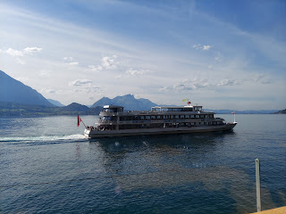

Some fellow travelers, waiting for our boat, used their face masks for a new purpose, ha ha.

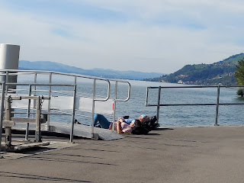

As the steamboat approached, I saw that Doris was right - it was very charming with the little toot-toot of the horn as it approached each stop.

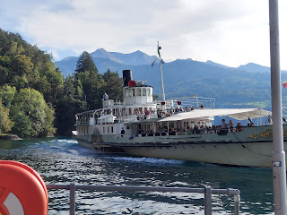

Action shot!! One of the crewmen is mooring the boat to the dock. (Nice lasso!)

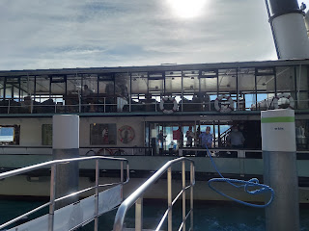

I bought my ticket once on board, and then found a place to sit out on the deck. I bought a 2nd class ticket for 13.50, as opposed to a 1st class ticket to sit on the upper deck for 22.50. Everything here is in Swiss francs. It's similar to the Euro, but a lot of places don't accept Euros here. I pay for what I can with my Visa card, and if they need cash, I have to give them paper Euros, not coins. Weird, but doable.

Video of the powers that propel the steamboat: (35 seconds)

https://photos.app.goo.gl/aDRwcqRZVcc2oWmw6

Swiss chalet style homes abound here

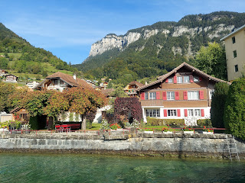

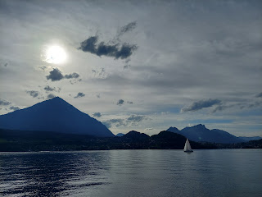

In the photo below, look at the two peaks that form a sort of saddle in between. I was at the top of the peak on the right. That's Niederhorn. If you look closely, you can see where the funicular goes up from the water's edge on the far right. (see next photo)

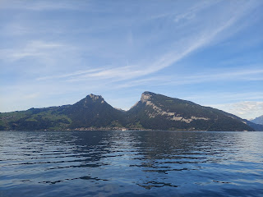

To the right of the white horizontal rocky area is a vertical line going up the mountain. That's the funicular.

The gondola took a 90 degree turn to go up to the top from there.

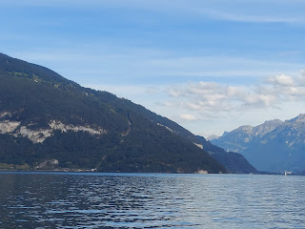

Oh, the lake views. :)

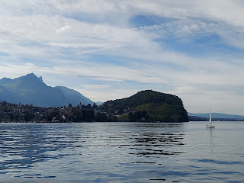

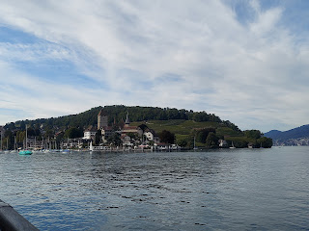

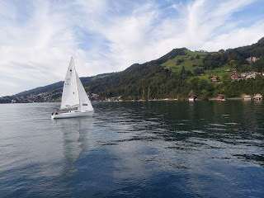

A new bride and groom. :)

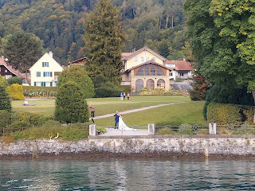

And many, many castles around Lake Thun.

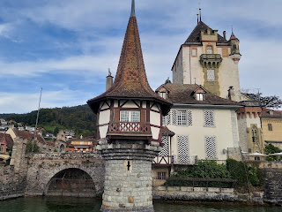

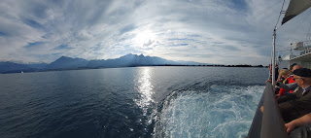

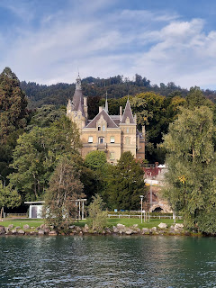

Video of us pulling up to the dock at Thun: (16 seconds)

https://photos.app.goo.gl/4g9nBu3tu5CtyyzV7

I disembarked, found some dinner, and hurried back to my lodging so I could watch general conference. (a religious conference twice a year where we can soak up words of counsel and love from our church leaders)

The view from my window at night. You can see Thun Castle up there.

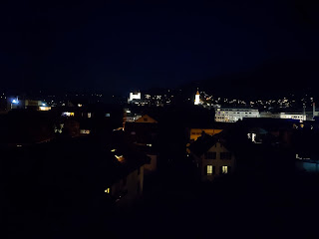

Sunday:

I had another horrible night of sleep. First, I had a lot on my mind from a conversation with a family member just prior to going to bed. I tossed and turned for some time. Then, I heard a mosquito buzzing in my ear again!! NOOOO!! Not this again!! It took me until maybe 3:30 or 4:00 a.m. to drop into some sleep finally. I slept in until maybe 9:30, until I heard all the church bells in town ringing and chiming for about 15 minutes straight! I guess they wanted everyone to get up and get to church!

I showered and got dressed, then worked on my blog some more. All the photos to sort through! :)

Around 2:30 I walked into town to tour the Thun Castle. It was wonderful!

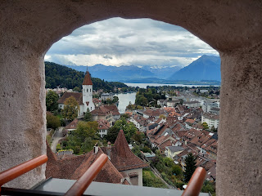

To see the rest of the photos, click on this link:

https://photos.app.goo.gl/RZbSRQUCNwhJWCrm8

I tried to take photos of the information being explained first, then the artifact. You'll also see photos from the upper level of the castle where volunteers, dressed in period clothing, were giving demonstrations. They shared what some of the common recipes would have been back in medieval times, how they did their weaving, etc. The table that I found most fascinating was where the lady explained how well the girls were educated back in those days. The girls were taught just as much as all the boys were!

She also shared that back then, they were taught that knowledge was power. The more knowledge they acquired, the more they would recognize God's hand in everything. What a powerful thought! So look carefully at the video of the lady explaining some of this, along with the photos of what the girls were being taught as a whole. It was so fascinating!

I also got to climb up into the castle turrets and look out the windows to see the land below. It was really invigorating to climb all the stairs and ladders to experience a tiny bit of the olden days. :)

The last grand adventure of the week was meeting up with Martin and his wife, Brigit, to have dinner together tonight. What a delight! They are such a treasure. They have a great sense of humor and are very kind and generous people. Not only did they pay for my meal, but they offered a place to stay when I come to Switzerland next time.

Here we are, sharing a meal together in Thun. I will never forget this!

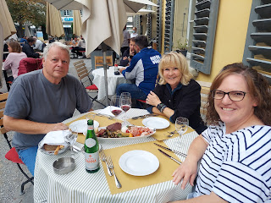

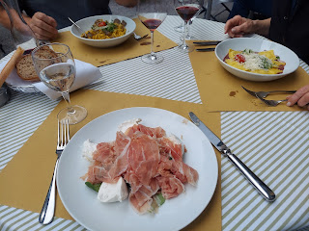

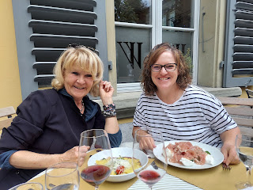

After two hours of lively and laughter-filled conversation, I walked home just in time to watch the next session of General Conference. What a great way to end the week. :)

